MINI GOLF TIPS.

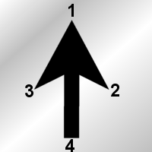
  1. Tip of the cursor | 2. Lower right tip of the cursor
  3. Lower left tip of the cursor | 4. Stub of the cursor

HOLE 1.

HOLE IN ONE. (accuracy medium)
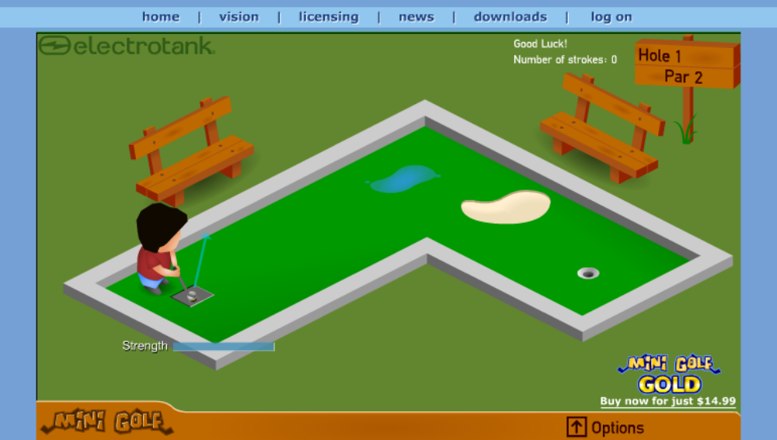Shot 1: aim the blue arrow so that the tip lies in the middle of the lightly shaded wall on the left.

HOLE 2.

HOLE IN ONE. (accuracy low)
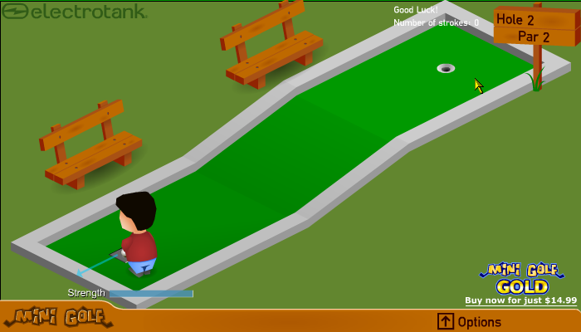
Shot 1: move the cursor to the hole and then slide it along the line of the slope until the stub touches the wall. (You don’t need to be too accurate)

HOLE 3.
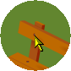
BIRIDE (-1) (accuracy medium)
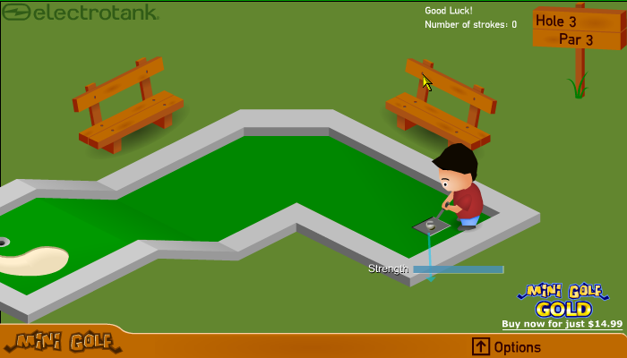
Shot 1: tip of the cursor over the top left nail of the nearest bench so that it’s just clipping the bottom right of the nail.
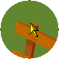
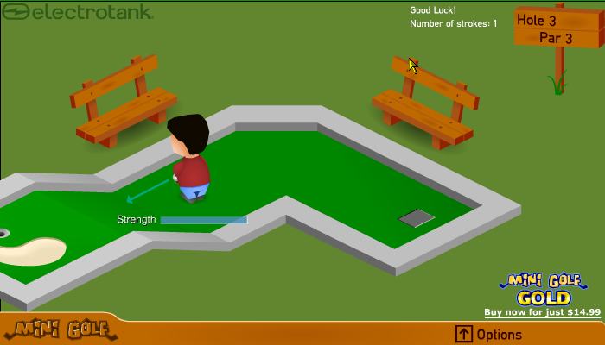
Shot 2: tip of cursor on the upper left part of the supporting back of the bench and the lower left tip of the cursor touching the right of the nail.

HOLE 4.
HOLE IN ONE (accuracy v low)
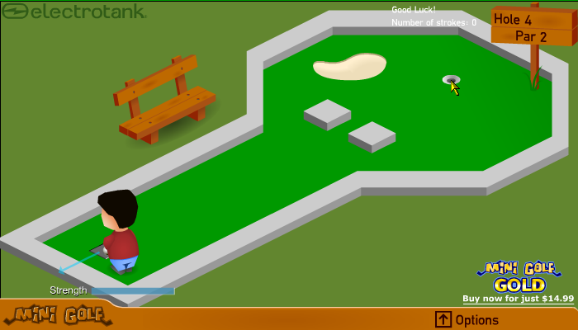
Shot 1: So easy it’s not worth using a large picture for accuracy. Just place the tip of the cursor over the hole, doesn’t need to be accurate.

HOLE 5.


HOLE IN ONE (accuracy high)
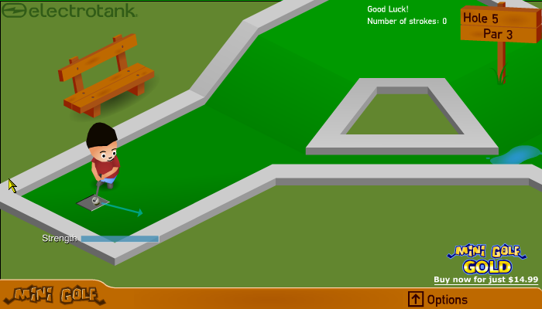
Shot 1: OK, stub of the cursor on the inner corner where the dark meets the light and the tip of the cursor touching the edge of the outer wall. (Gotta love it)

HOLE 6.

BIRDIE (accuracy medium)

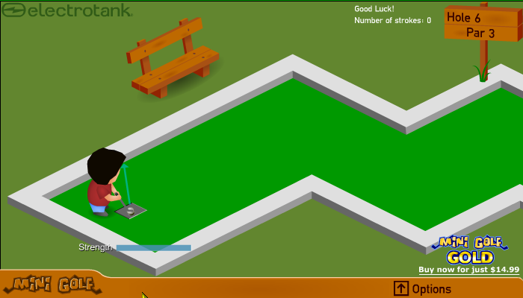
Shot 1: one where it’s good to be Rob. Line up the blue arrow’s left side of the head so that it line’s up with Rob’s hairline. Or make it so that the tip of the aimer just nearly touches the inner wall.
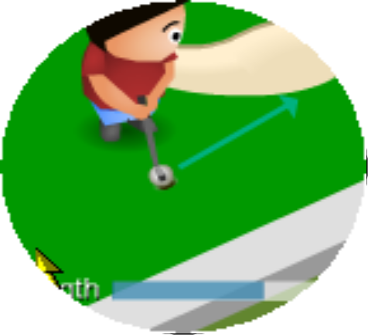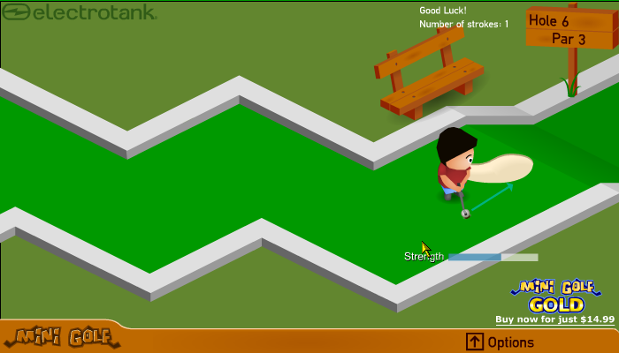
Shot 2: Now line up the aimer so that its lower left tip at least touches the bunker and the edge of the strength is touching the outer wall.

HOLE 7.

HOLE IN ONE (accuracy VERY HIGH)
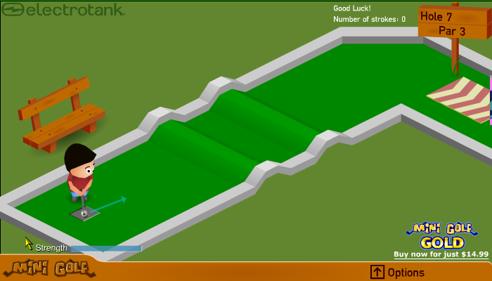
Shot 1: place the lower right tip of your cursor right on the very top of the ‘S’ in strength and then keep sliding it left until the strength gauge is JUST full, I’m talking a pixel’s difference here. Then just click away. Easy no? All right I’ll give u a close up then.

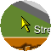

LOOK, THE LOWER RIGHT TIP OF THE CURSOR IS JUST TO THE LEFT OF THE ‘S’

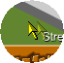
HOLE 8.

HOLE IN ONE (accuracy VERY HIGH)
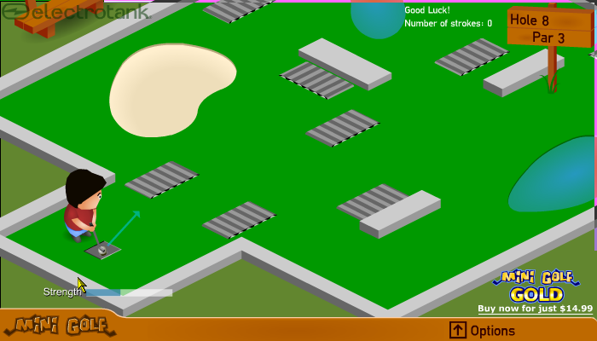
Shot 1: place the lower left corner of the cursor right on the bit where the downward line on the ‘h’ in strength meets. Ugh I’ll just show a zoomed in pic. At least this method definitely works!

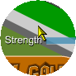

There, how’s that.

HOLE 9. (Halfway!)

BIRDIE (accuracy high)

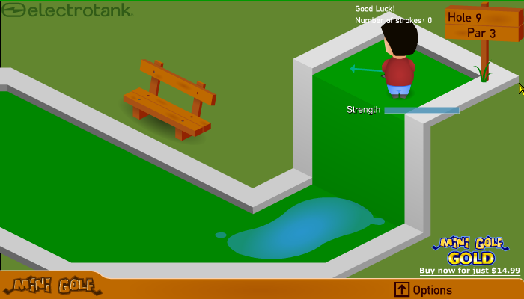
Shot 1: Tip of cursor on the right, outer corner of the dark-shaded bit.

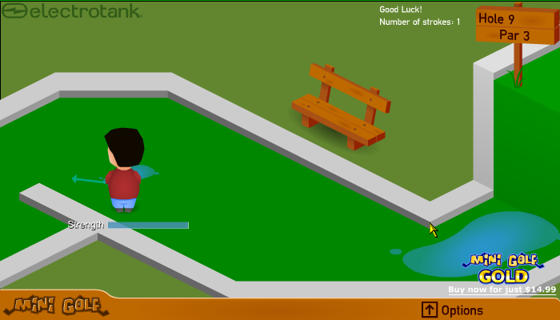
Shot 2: Tip of cursor on the bottom left corner near the puddle, click on the bit where the white, grey and dark grey join.

HOLE 10.
HOLE IN ONE (accuracy high)
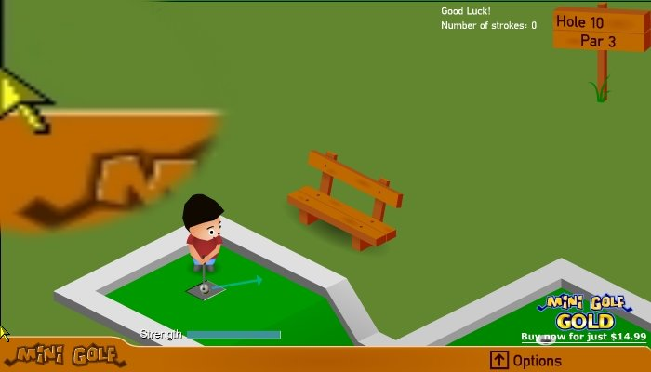
Shot 1: Move the screen position to the very top right so that it has to reset itself. Then just move the cursor to the very far left and line up the lower right tip so that its 1 pixel above the orange bar at the bottom of the screen.

HOLE 11.

BIRDIE (accuracy high)
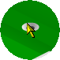
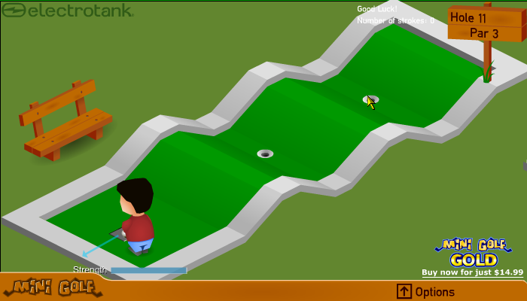
Shot 1: place cursor over second hole so that the tip and bottom right tip are touching the outside of the hole and the bottom left tip and the stub are touching the base of the slope.
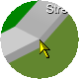
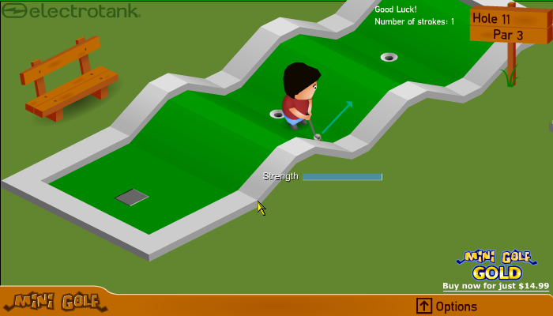
Shot 2: tip of cursor on outside top right corner nearest starting block, click part where dark grey, light grey and white join, MAYBE a pixel lower just to make sure though.

HOLE 12.

HOLE IN ONE (accuracy VERY HIGH)
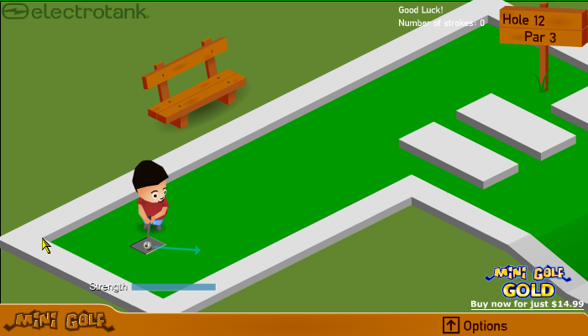
Shot 1: tip of cursor so that it’s JUST over the top left inside corner, 1 pixel’s difference. (Believe me it can be a bugger when you just miss the hole!)

HOLE 13. (Unlucky for some)
HOLE IN ONE (accuracy high)
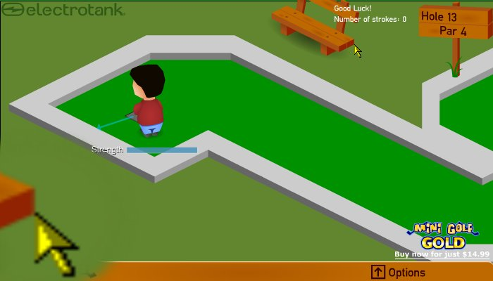
Shot 1: tip of cursor on bottom part of the far right corner on the base of the bench
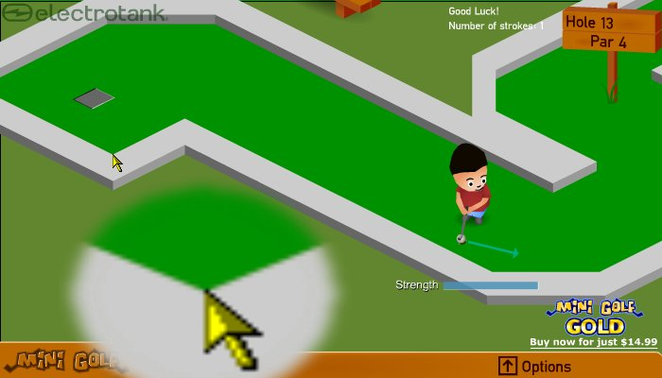
Shot 2: Tip of cursor on the corner to the lower right of the grey starting box.

HOLE 14.


BIRDIE (accuracy VERY HIGH)
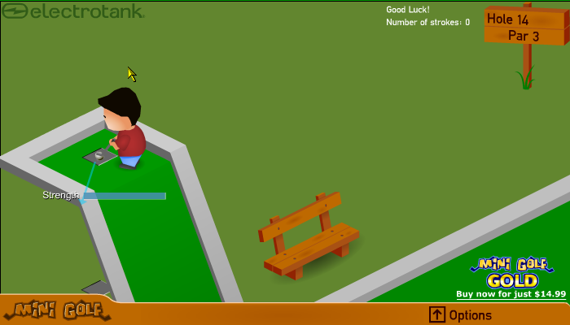
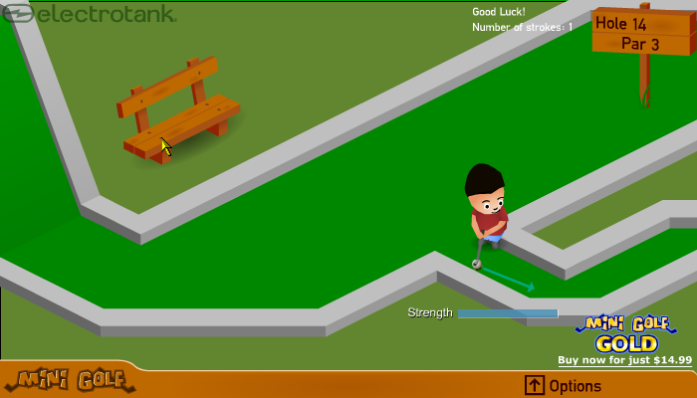
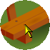
Shot 1: line up that aimer so that the bottom right tip touches the bottom right of the ‘h’ on ‘strength’ and the bar clips the top left and bottom right corner of the strength gauge.
Shot 2: tip of the cursor on the bottom left nail of the bench, right at the top, middle of the nail.

HOLE 15.

EAGLE (accuracy high)
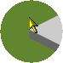
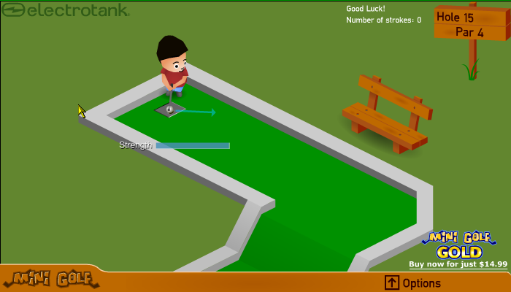
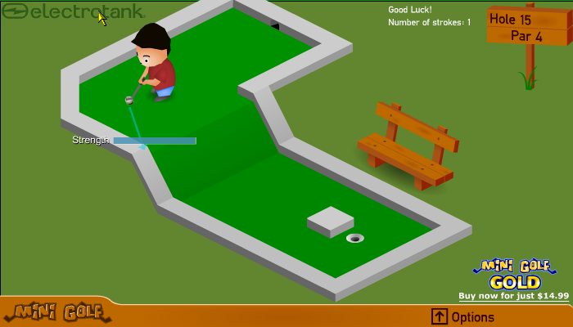

Shot 1: lower left tip of cursor on the far left outside corner
Shot 2: lower left tip of aimer touching the strength bar, make sure it’s ATLEAST touching.

Hole 16.

ALBATROSS!!! (accuracy high)
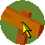
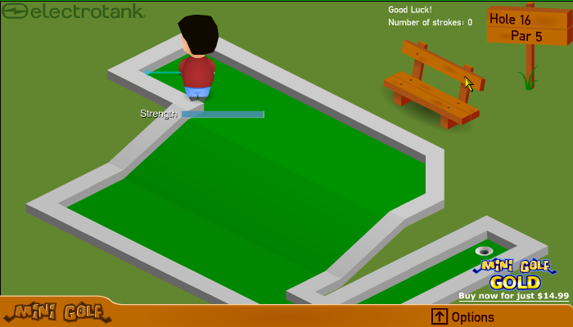
Shot 1: tip of cursor on tip right nail covering the whole right hand side of the nail.
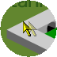
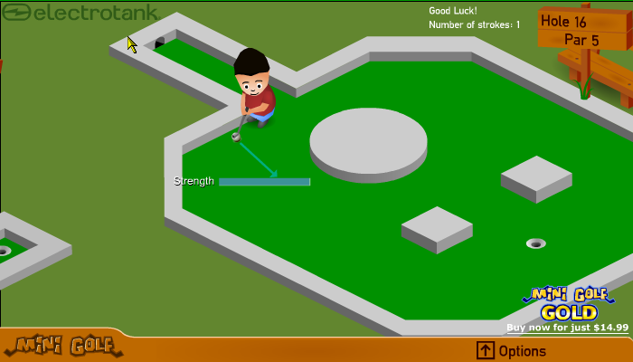
Shot 2: move the lower right tip of your cursor to the top left inner corner right next to where your ball should come through had you not CHEATED!…then slide your cursor to the left until the tip touches the outer wall, you may need to move it 1 more pixel left to make sure it goes in, infact I advise you do that!

HOLE 17.

HOLE IN ONE (accuracy VERY HIGH)
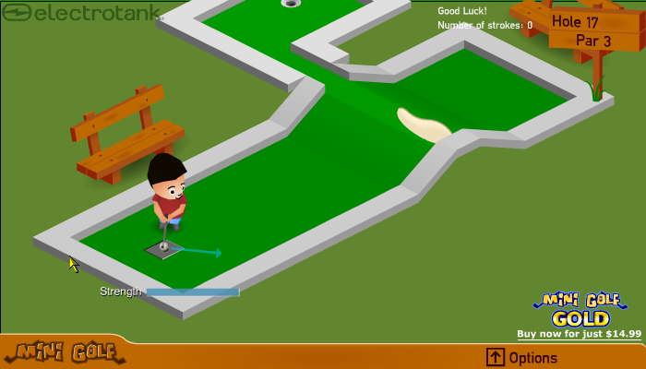
Shot 1:place tip of cursor on top left inside corner and then move it down carefully until the tip touches the dark-shaded bit.
Quite difficult.

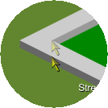

That’s what you do

HOLE 18!

BIRDIE (accuracy high)
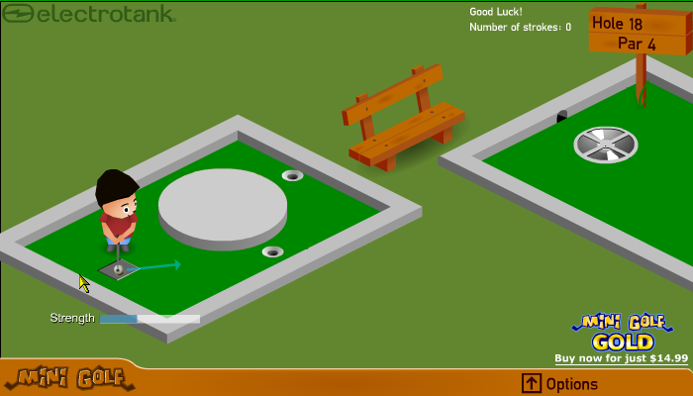
Shot 1:aim for nearest hole, come on, even you can do that!
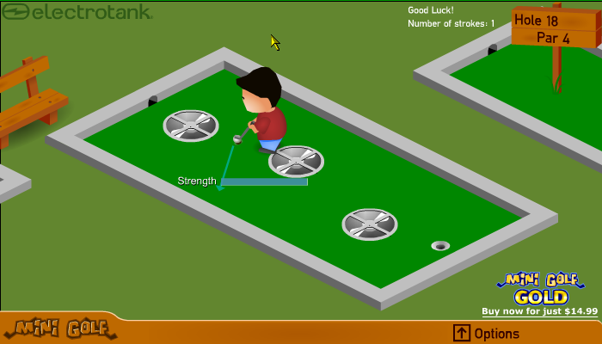
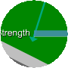

There now you see
Shot 2: aim the arrow so that it goes through the bottom left corner of the strength bar
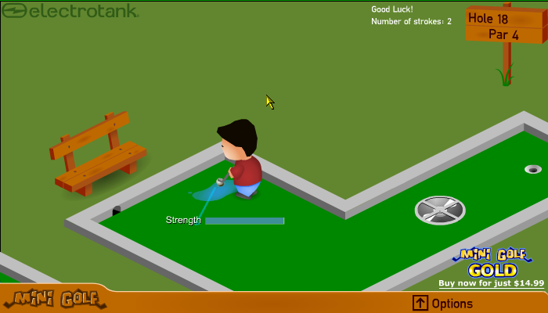
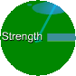ta da!
Shot 3: aim so that the arrow is in the ‘th’ of ‘strength’
HOLE 18: ROUTE 2 (accuracy VERY HIGH)
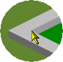
Shot 1: aim for other hole
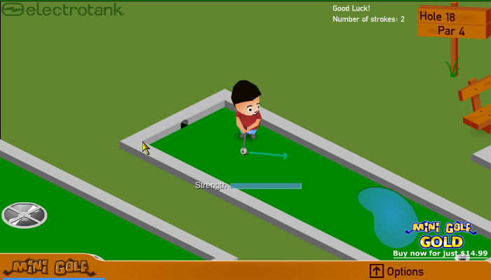
Shot 2: tip of cursor at the inside corner to the left of the hole you came through

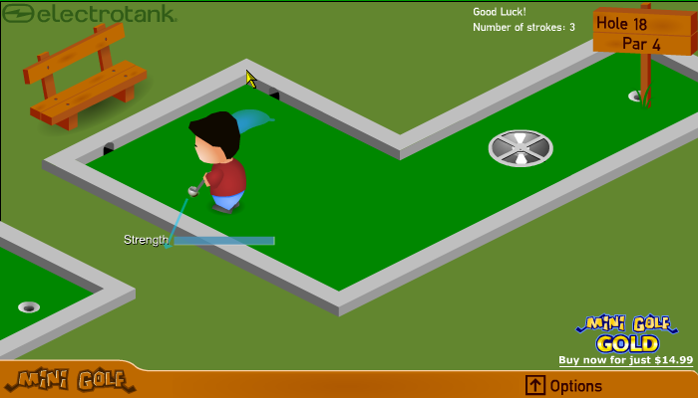
Shot 3: lower right tip of cursor on lowest part of the corner to the left of the hole that you didn’t come through.

CONGRATULATIONS!
YOU HAVE COMPLETED
ELECTROTANK’S MINI GOLF
AND HOPEFULLY ACHIEVED A SCORE OF
-28!!!!!!!!!!

